Project Group Two - Gary Sopko, Malik Khouma, Chi Nam Tran

BUS 340

Professor Lacy

13 October 2021

Wildfires and Effects on AQI

**Links to Tableau Workbooks**

[Link to BUS 340 - Group 2: Wildfire and AQI Workbook in Tableau Online](https://10ay.online.tableau.com/#/site/ericlacyuniversityofsanfrancisco/workbooks/917457?:origin=card_share_link)

[Link to BUS 340 - Group 2: Wildfire and AQI Workbook packaged workbook in Google Drive](https://drive.google.com/file/d/1-54Pk3p5jc9gvYHBSU-xjrAf0ksZzrAg/view?usp=sharing)

**Introduction & Background**

As a group, we really wanted to find a topic that would be both interesting and impactful. We scoured databases of datasets, looking for something relevant to our lives. After discussing different possibilities, we got onto the topic of air quality, something that affects not only us, but everyone on Earth. We originally made air quality the primary focus of our research, but at some point we realized that the data we had simply couldn’t support a project of this magnitude. The data went into incredible depth, but it was too narrow. It only had data available for one year at a time, which wasn’t nearly enough to look at trends. We got together and reassessed. Air quality and the work we’d already done could be something we included in our final analysis and visualizations, but we needed a new primary focus. We started looking at related factors, anything that would impact or be impacted by air quality. Natural disasters were something we felt could potentially contribute to negative air quality, specifically wildfires, which introduce ash and massive amounts of particulate matter into the air. Gary found us a wildfire dataset with data by state for the last ten years, so we could look at trends by state as well as comparing annual values from state to state.

**Top States for Wildfires and Acres Burned**

The wildfire data covered all states, but that scope was a little too broad. We made an initial map of the United States with two values for each state. The state is filled in with a hue based on the total number of acres burned by wildfires in the selected years, while the inner dot is colored based on the number of distinct reported wildfires the state had in the given time period. Looking at this visualization, it’s clear that we were right to ignore the majority of states. An overwhelming percentage of fires occurred in the Western region of the United States. Additionally, although Washington, Oregon, Nevada, New Mexico, and Idaho outstrip any of the other states in the South, Midwest, or East Coast, they all pale in comparison to California, the only state with high enough acres burned and number of wildfires to rank at a deep red. This made our decision to focus on the top ten states rather easy, as anything beyond that appeared to be a non-problem in terms of potential solutions.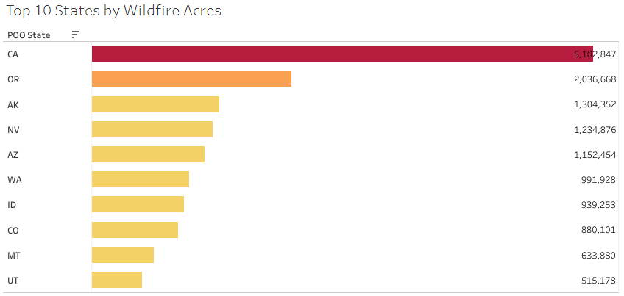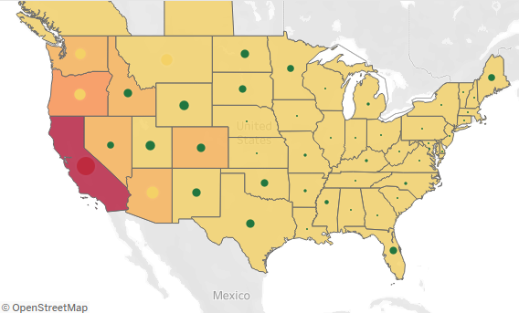

California is by far the largest problem state with more than twice as many acres burned as the next highest, Oregon. Oregon in turn has more than twice as many as Washington, which has about two times the number as Utah. This is an intuition that the members of our team had, but figured that it may have been skewed by our media consumption, living on the West Coast. After backing our hypothesis up with evidence, we decided to move on to our original topic, air quality, to see if the areas with the worst air quality matched up with those with the highest wildfire incidence.

**Top States for Poor Air Quality**

For our air quality analysis, we decided to start in much the same way. Air quality index, or AQI, is measured on a scale of 0-500, with higher values indicating higher density of pollutants in the air, and as such, worse air. We made two map charts, one showing the median AQI by state, and the other showing the highest AQI in that state in the given time period.

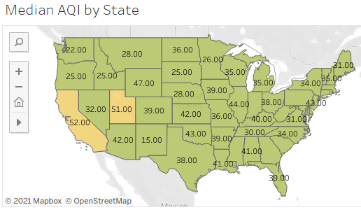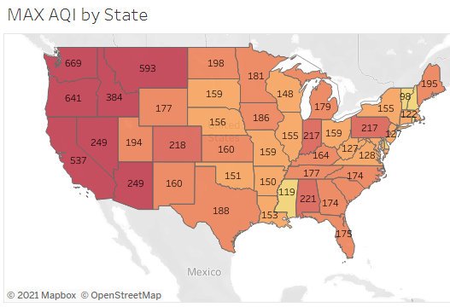

As you can see, all states other than California and Utah are green when looking at the median AQI. Green indicates an AQI of 50 or under, which the Environmental Protection Agency considers as the range of “good” air quality, with anything higher being considered as increasing degrees as harmful. California and Utah each barely have a median above 50, but that’s enough to consider the air quality “moderate” on average rather than good. The max AQI map is slightly more meaningful, with the prominent wildfire states (and Montana) showing a max rating of “hazardous” (301+), with several even breaking through the normal scale max of 500. This is interesting, because it indicates that something caused *awful* air quality, without being prolonged enough to impact the median. Looking at our wildfire map, it seems plausible that those fires were in fact the cause of the brief sky-high AQI, although we would require more specific data, and lots of it to confirm our suspicions.

**Actionable Recommendations**

With the clear concentration of wildfire devastation on the West Coast, and especially California, it’s obvious that something needs to be done. The specific answer has yet to be found, however in the meantime, the best course of action moving forward is to dedicate additional funds to research on wildfire prevention in California, Washington, and Oregon, and resource allocation to mitigating damage of wildfires all along the West Coast, in an effort to protect lives and property. Additionally, wildfire prevention would likely reduce the AQI, leading to an increased standard of living for all in the area, even those who aren’t in immediate proximity to the fires.

**Data Sets**

To analyze wildfire and AQI data we sourced data from the US Environmental Protection Agency and the National Interagency Fire Center. The data sets published by these agencies contained air quality and wildfire data for the past several years.

The wildfire data analyzed was provided by the National Interagency Fire Center on their data portal on their website ([National Interagency Fire Center - WFIGS - Wildland Fire Locations Full History](https://data-nifc.opendata.arcgis.com/datasets/wfigs-wildland-fire-locations-full-history/explore?location=-0.000000%2C0.000000%2C0.00)). The National Interagency Fire Center is a US government agency focused on providing unified guidance, training, and handbooks for common fire procedures. Over the past several years they have become a coordination center for fires in the United States, and have curated a common data set that contains data about wildfires across the country that can be mapped using tools such as Tableau.

The wildfire data set contains data from every wildfire event across every county and state, including some provinces in Canada and Mexico. Key variables in the data set include the date and time the fire occurred, the country, state, and county the fire occurred in, the number of acres burned in the fire, and the number of fires that occurred in each area. The data set analyzed has a total of 201,585 rows and includes data starting from 2013 to middle of 2021. There were many additional variables included in the data set that we did not analyze, such as the cause of the fire, what type of land the fire occurred on (private, US Forest Service, etc), and the date and time when the fire was contained.

Our air quality data set was provided by the United States Environmental Protection Agency. The US EPA posts daily AQI data for the past forty years on their [United States Environmental Protection Agency Air Data Pre-Generated Data Files](https://aqs.epa.gov/aqsweb/airdata/download_files.html#AQI) website. This data is collected from individual air quality reporting stations across the US.

Despite having over 40 years of air quality data being provided by the EPA, we decided to focus in on the last 6 years worth of data (from 2015 - 2021). We focused on the last 6 years of data and because wildfire data is not available before 2013 and is very inconsistent before 2015. The daily AQI data between 2015 and 2021 contains 2,064,635 rows of data. It is a much more basic data set with key variables being the state and county reporting the AQI, the AQI for the region, the date the AQI was reported, and how the AQI parameter is defined (PM2.5 vs Ozone vs CO2).

Using the wildfire and AQI data together, we are able to create a visualization that shows the states and counties being hit hardest by wildfires and AQI. By comparing and layering these two data sets we are able to find patterns that will help the US EPA and National Interagency Fire Center make recommendations on where the US Government should focus research, projects, and supplies to improve wildfire prevention and air quality in these areas.

**Summary & Conclusion**

We believe wildfire and poor air quality are one of the most current important issues that needs to be addressed especially in the United States. In order to start our research we needed to collect data from the US Environmental Protection Agency and National Interagency Fire Center. Using these datasets, we were able to map all the states wildfire records, acres burned and its AQI in selected years.

At the end of our research we have found that California is by far the state which has the most wildfires and poor air quality with over 5 million acres of wildfire acres recorded and measuring above 500 on the max AQI map. We can assume there is a correlation between the wildfires and the poor air quality. The best course of action we recommend after receiving these results is to dedicate more funds to wildfire prevention in states such as California, Washington and Oregon.

**Works Cited**

“Air Quality - Cities and Counties.” *EPA*, Environmental Protection Agency,

www.epa.gov/air-trends/air-quality-cities-and-counties.

“Asthma Surveillance - United STATES, 2006–2018.” *Centers for Disease Control and*

*Prevention*, Centers for Disease Control and Prevention, 16 Sept. 2021, www.cdc.gov/mmwr/volumes/70/ss/ss7005a1.htm?s_cid=ss7005a1_w.

“EPA AQI Download Data.” *EPA*, Environmental Protection Agency,

aqs.epa.gov/aqsweb/airdata/download_files.html#AQI.

“Most Recent Asthma State Data.” *Centers for Disease Control and Prevention*, Centers for

Disease Control and Prevention, 30 Mar. 2021, www.cdc.gov/asthma/most_recent_data_states.htm.

“OpenFEMA Data Sets.” *FEMA.gov*, www.fema.gov/about/openfema/data-sets.

“WFIGS - 2021 Wildland FIRE Locations to Date.” *National Interagency Fire Center*,

data-nifc.opendata.arcgis.com/datasets/wfigs-2021-wildland-fire-locations-to-date/explore?location=0.000000%2C0.000000%2C0.00&showTable=true.

**Group Contributions**

* Gary Sopko
  + Data gathering
  + Dataset description
  + Chart drafting
  + Tableau lead
* Nam Tran
  + Visualization plan
  + Group contributions
  + Summary and Conclusions
* Malik Khouma
  + Introduction and background
  + Data analysis summary
  + Actionable recommendations
  + Works Cited